PENETRATION TESTING REPORT

Client: Mediroza General Hospital
Target: https://medirozahospital.com
Assessment Type: Black-Box Penetration Test
Duration: 5 Days.
Project: Networkwalks – Batch B083, Week 4.
Testing Status: Authorized Security Assessment.

Executive Summary
A black-box penetration test was conducted against the Mediroza General Hospital web application to identify security weaknesses that could allow unauthorized access to restricted information.
The assessment followed the authorized project scope provided by Networkwalks. The objective was to identify exposed entry points, assess authentication mechanisms, test how the application handles user input, and determine whether restricted patient information could be accessed.
During testing, a SQL Injection vulnerability was successfully identified on the patient login portal. The vulnerability demonstrated that the application did not properly handle maliciously crafted input submitted through the login functionality. A public directory listing exposed database backup URL:/OLD .The file was accessible without authentication through the /old/directory.
Successful exploitation of this vulnerability represents a significant security risk because an attacker may potentially bypass authentication and gain access to restricted areas or sensitive patient information.
The project brief identifies the retrieval of three confidential patient PDF laboratory reports as the first major milestone.
Overall, the identified SQL Injection vulnerability should be treated as a Critical risk because the affected functionality is an authentication portal within a healthcare environment and may provide access to sensitive patient information.

Scope and Methodology
2.1 Scope
The assessment targeted: https://medirozahospital.com
The engagement was defined as a full black-box penetration test. The test was required to identify vulnerabilities, demonstrate their impact through controlled exploitation, and document the findings.
Testing Restrictions
The following restrictions applied:
- Testing was limited to the target domain.
- No social engineering was performed.
- No denial-of-service testing was performed.
- Testing outside the agreed scope was not permitted.
- Written authorization was provided for the assessment.
2.2 Methodology
The assessment followed a black-box penetration-testing approach:
- Reconnaissance
- Identification of exposed entry points
- Analysis of authentication mechanisms
- Input validation testing
- Controlled exploitation of identified vulnerabilities
- Evidence collection
- Risk assessment
- Remediation recommendations
The project milestones required initial access, extraction and analysis of retrieved files, investigation of further exposure, and preparation of a professional penetration-testing report.
2.3 Tools
Tools used during the assessment included:
- Burp Suite
- cURL
- Nmap/reconnaissance tools
- SQL Injection testing techniques
- Other authorized web-application testing tools

The first project milestone required the tester to conduct reconnaissance, identify exposed entry points, analyse authentication mechanisms, test input handling, and gain unauthorised access to a restricted area.
During the assessment, the patient login portal was identified as an important attack surface
Testing of the login functionality resulted in successful SQL Injection exploitation

3. Findings and Proof of Exploitation
Finding 1 : Public directory listing and exposed database backup URL:/Old/
Description:
Public directory listing occurs when sensitive or confidential information is unintentionally made accessible through publicly available directories, web pages, file listings, or online databases. This may expose information such as employee details, shareholder records, contact information, internal documents, system information, or other organizational data to unauthorized individuals.
Exposed File: mediroza_db_backup_2019 sql Unauthorized access to database information. The file was accessible without authentication.
Impact: The exposed potentially allows an unauthorized visitor to obtain confidential organizations data.
Proof of concept:
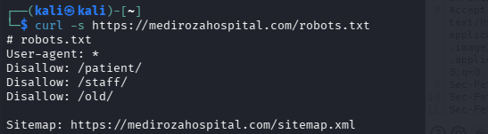
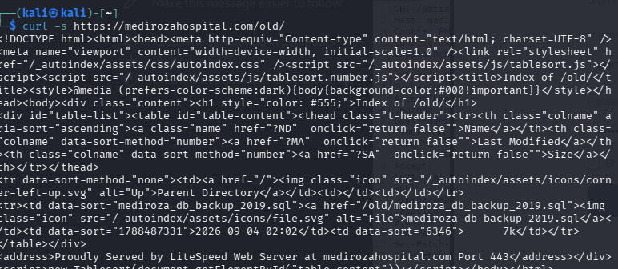
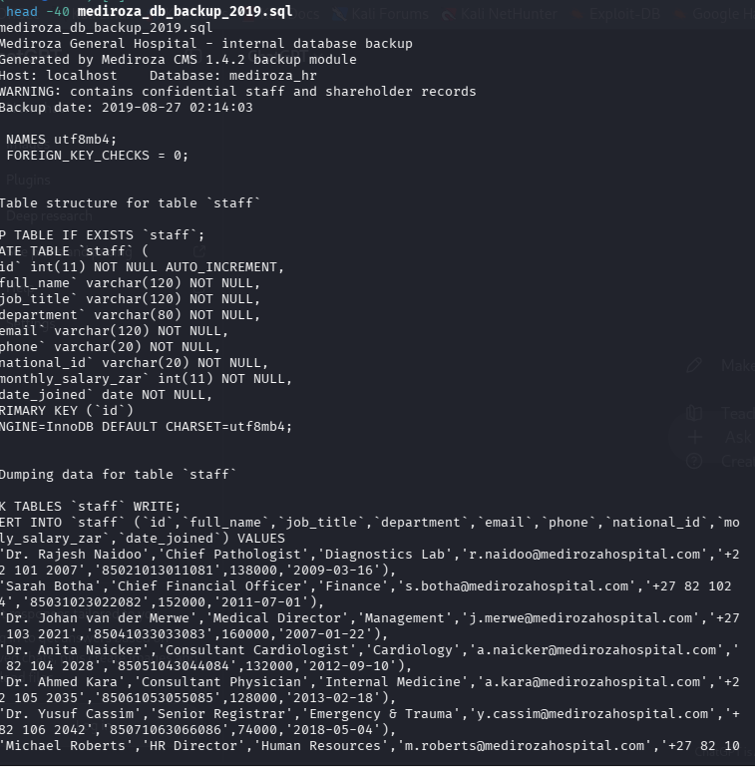
Finding 2: Sensitive Information exposure Shareholders Records.
Description:
Sensitive information exposure involving shareholders’ records occurs when confidential shareholder data is accessed, disclosed, shared, or made available to unauthorized individuals or parties. Such records may contain personal and financial information, including shareholders’ names, contact details, shareholdings, ownership percentages, identification information, dividend details, or other confidential corporate records.

Evidence: Public directory listing permitted retrieval of an internal, database backup which contains staff table, shareholder information including salary data
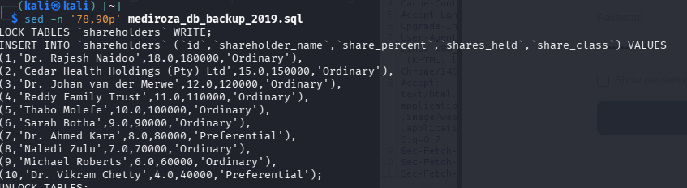
Impact: An unauthorized party who can retrieve the exposed database backup could access confidential shareholder compensation information.

Finding 3: SQL Injection in Patient Login Portal
Description
A SQL Injection vulnerability was identified in the patient login functionality.
The application accepts user-controlled input through the login form. Testing demonstrated that specially crafted input could alter the application's interaction with the underlying database.
The successful test indicates that the application does not adequately validate or safely process input before using it in a database query.
Impact
- An attacker could potentially use this vulnerability to:
- Bypass authentication controls.
- Access restricted patient areas.
- Retrieve sensitive information from the database.
- Access confidential patient records.
- Potentially modify or manipulate database information, depending on the application's database privileges.
Because the affected system belongs to a healthcare organization, unauthorized disclosure of patient information could have serious confidentiality and privacy implications.
Proof of Exploitation
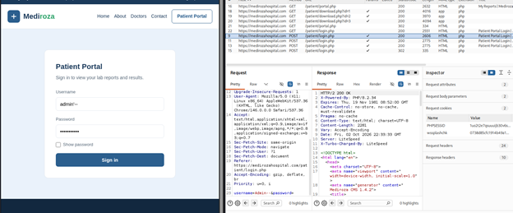
The SQL Injection was tested against the patient login portal.
Result: Successful.
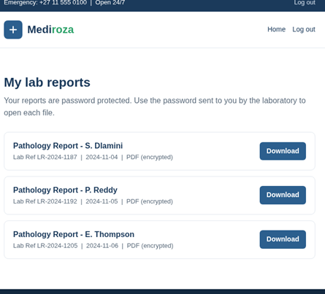

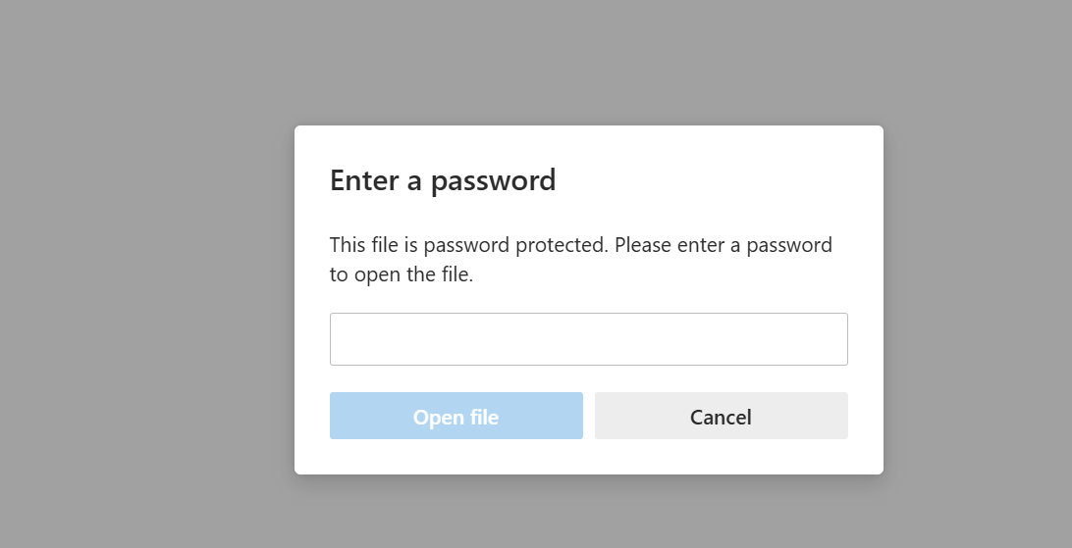
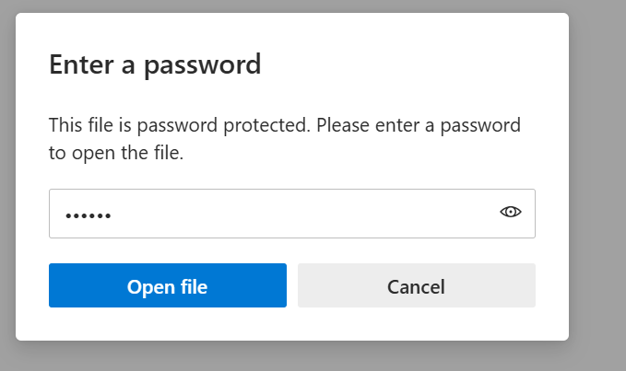

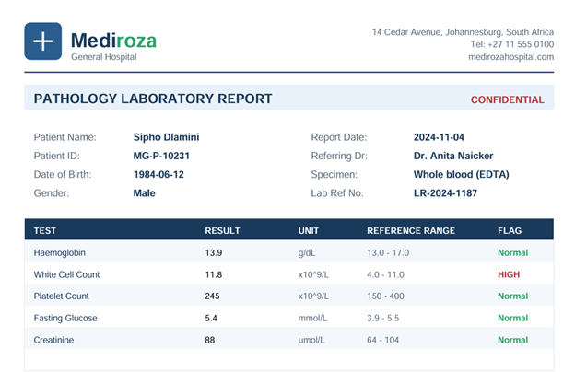
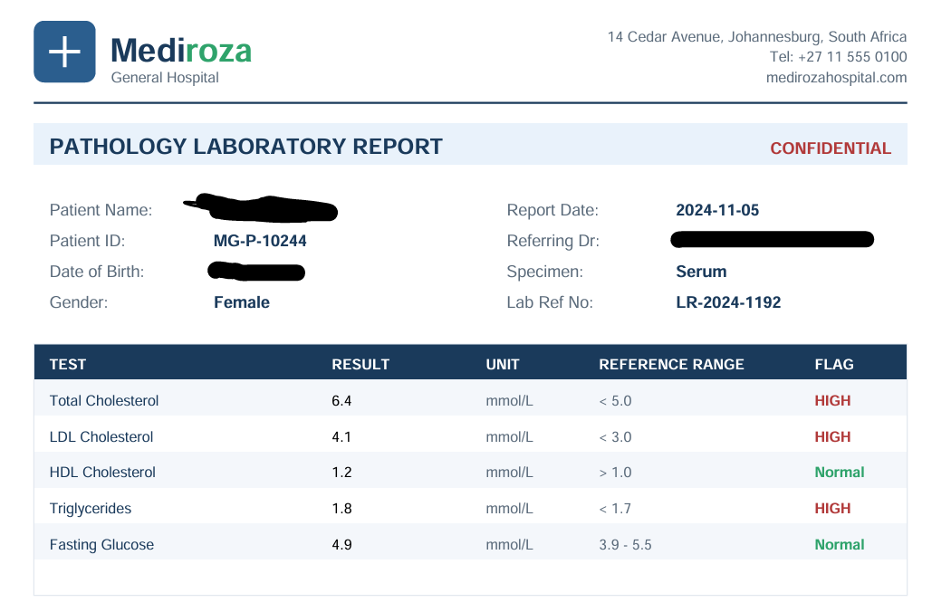
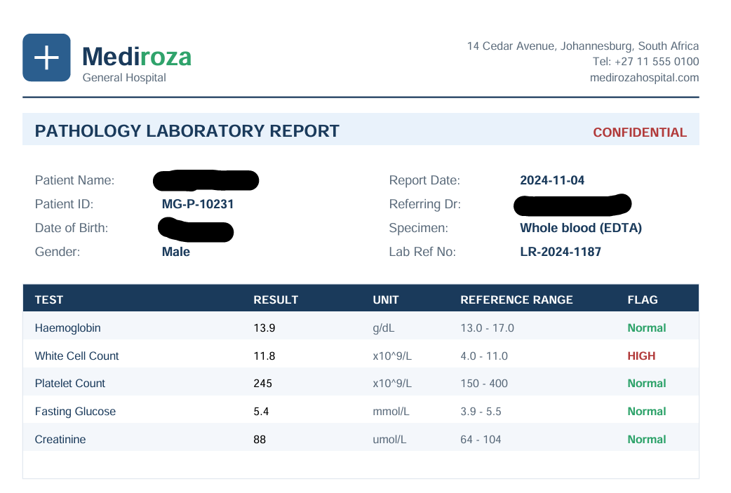
Impact:
SQL injection can lead to unauthorized access, exposure, modification, or deletion of sensitive database information, potentially causing financial loss, operational disruption, reputational damage, and regulatory consequences.

 | Vulnerabilities | Location | Risk
1 | SQL injection login bypass | patient/login.php | Critical
2 | Encrypted PDFs accessible after login bypass | patient/reports/ | High
3 | Weak PDF passwords crackable with a wordlist | patient_report_*.pdf | High
4 | Forgotten backup folder with directory listing enabled | old/ | Critical
5 | Confidential staff salaries and shareholder data in plain text | old/mediroza_db_backup_2019.sql | Critical
6 | Username enumeration on login page | patient/login.php | Medium

Risk Rating

Critical

The vulnerability is rated Critical because it affects an authentication mechanism and may provide unauthorised access to sensitive healthcare information.

--- Severity: Critical
Category: Injection / SQL Injection
Affected Component: Patient Login Portal
Status: Successfully Exploited

4. Milestone 1 – Initial Access

The first project milestone required the tester to conduct reconnaissance, identify exposed entry points, analyse authentication mechanisms, test input handling, and gain unauthorised access to a restricted area.

During the assessment, the patient login portal was identified as an important attack surface.

Testing of the login functionality resulted in successful SQL Injection exploitation.

Milestone 1 Result

Status: COMPLETED

Evidence:

- Patient login portal identified.
- Authentication mechanism tested.
- SQL Injection vulnerability identified.
- Vulnerability successfully exploited.
- Evidence captured for reporting.

---

5. Milestone 2 – Data Extraction

The second milestone required analysis of the retrieved files and recovery of the contents of all three encrypted PDF laboratory reports.

Assessment Result

Status: [COMPLETED / IN PROGRESS]

The three retrieved PDF files should be documented individually.

File| Encryption Identified| Access Recovered| Evidence
Patient PDF 1| [Yes/No]| [Yes/No]| Screenshot
Patient PDF 2| [Yes/No]| [Yes/No]| Screenshot
Patient PDF 3| [Yes/No]| [Yes/No]| Screenshot

Note: The actual contents and recovery results should be inserted from the evidence collected during the assessment.

---

6. Milestone 3 – Critical Data Exposure

The third milestone required further analysis of the information retrieved during the assessment to identify additional critical exposure on the server.

The project specifically required investigation of:

- Hospital employee salaries.
- Hospital shareholder details.

Assessment Result

Status: [COMPLETED / IN PROGRESS]

Evidence

The following should be documented if successfully identified:

Employee Salary Information:
[Insert verified finding and evidence]

Shareholder Information:
[Insert verified finding and evidence]

Source/Location:
[Insert URL, file, directory, database or other verified source]

Screenshots should be included to demonstrate the exposure while avoiding unnecessary disclosure of sensitive personal information.

---

7. Risk Summary

Finding| Severity| Status
SQL Injection – Patient Login Portal| Critical| Successfully Exploited
Exposure of Patient PDF Reports| [To be confirmed]| [Status]
Weak/Crackable PDF Encryption| [To be confirmed]| [Status]
Employee Salary Exposure| [To be confirmed]| [Status]
Shareholder Information Exposure| [To be confirmed]| [Status]

The final risk rating should be based on the actual evidence obtained during the assessment.

---

8. Recommendations and Remediation

8.1 Remediate SQL Injection

The SQL Injection vulnerability should be addressed immediately.

Recommended actions include:

- Use parameterised queries/prepared statements.
- Do not concatenate user input directly into SQL queries.
- Implement strict server-side input validation.
- Apply appropriate input encoding where required.
- Use database accounts with the minimum privileges necessary.
- Implement secure error handling so database errors are not exposed to users.
- Conduct a full review of other application inputs for similar vulnerabilities.

8.2 Strengthen Authentication

The patient portal should use strong authentication controls, including:

- Secure session management.
- Account lockout/rate limiting where appropriate.
- Secure password storage.
- Multi-factor authentication where appropriate.
- Protection against authentication bypass.
- Continuous monitoring of suspicious login activity.

8.3 Protect Patient Documents

Patient laboratory reports should not be publicly accessible or predictable through direct URLs.

Recommended controls include:

- Enforce authorisation checks before serving files.
- Store sensitive files outside the public web directory where possible.
- Use unpredictable file identifiers.
- Apply access-control checks on every document request.
- Encrypt sensitive files appropriately.
- Log and monitor access to patient records.

8.4 Protect Sensitive Business Information

Employee salary information and shareholder information should be restricted to authorised personnel.

Access should follow the principle of least privilege, with appropriate authentication, authorisation, logging and monitoring.

---

9. Conclusion

The penetration test identified a Critical SQL Injection vulnerability in the Mediroza General Hospital patient login portal. The vulnerability was successfully exploited during the authorised assessment.

The finding demonstrates that inadequate input handling within an authentication function can create a path to unauthorised access and potentially expose sensitive healthcare information.

The SQL Injection vulnerability should therefore be remediated as a priority. Following remediation, a validation test should be performed to confirm that the vulnerability has been completely resolved.

The remaining project milestones should be reported using the actual evidence collected during testing, particularly the three patient PDF reports, their encryption status, and any verified employee salary or shareholder information exposure.

---

Appendix A – Evidence

Screenshot 1 – Patient Login Portal

Description: Login page identified during reconnaissance.

[Insert screenshot]

Screenshot 2 – SQL Injection Request

Description: Request demonstrating the SQL Injection test.

[Insert Burp Suite/cURL screenshot]

Screenshot 3 – Successful Exploitation

Description: Evidence demonstrating successful exploitation.

[Insert screenshot]

Screenshot 4 – Retrieved Patient PDF

Description: Evidence of authorized test access to the retrieved PDF.

[Insert screenshot]

Screenshot 5 – Additional Data Exposure

Description: Evidence of any further confirmed sensitive-data exposure.

-

Appendix B – Assessment Limitations

The assessment was performed under the restrictions defined in the engagement brief. Testing was limited to the authorized target domain, with no social engineering or denial-of-service testing.

Where evidence was not available or a finding could not be independently confirmed, it should not be reported as a confirmed vulnerability.

Confidentiality Notice: This report contains information relating to security testing of a healthcare web application and should be restricted to authorized personnel.

